Login Screen:

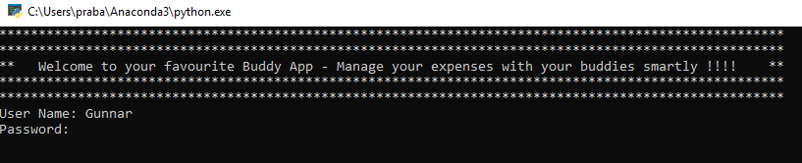

This app is initialized with few users by default. Users “Gunnar”, “Chris”, “Rob” don’t have a password.

Here is the initial screenshot with the options:
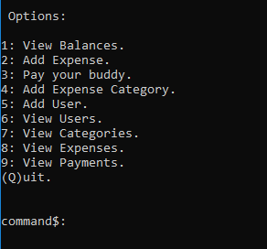

I have implemented almost all the functions that was originally planned. As Gunnar mentioned in the earlier feedback, implementing advanced functions such as group expenses , recurring expenses needed more time as the program was getting bigger and complex.

Here are the classes that was planned and implemented.
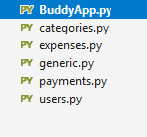
- View Balance – Shows all the balances owed by each users to others.
- Add Expense – It is the main function of this program

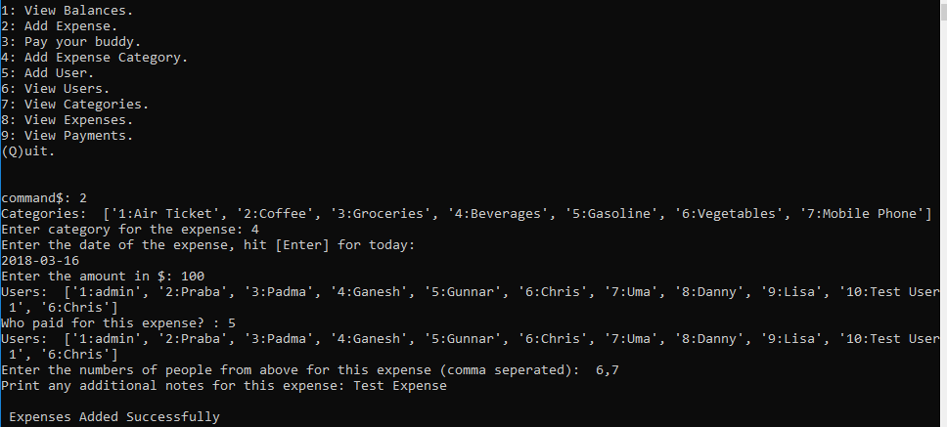
This displays the category to be picked. User is expected to enter the number next to the category. Next the date to be entered, by default it will store the today’s date. Then the expense amount, paid by user and the paid for users (comma separated). If there is more than one user this expense is paid for , the amount will be equally split between the users.
For the data persistence, to make it a simple approach, I used pickle package. This works in a simple way to serialize the objects and store it in a file for later retrieval. First time I used Microsoft Visual Studio for the python code development, it worked very well to debug and step by step execution of the code. Adding watch to the variables and checking the value to fix the logic became easier in using the visual studio.
Originally, I wasn’t thinking the collection object for expense, payment, user and categories. But later I thought it would be easier to create a collection object for each type such as expenses object that holds the collection of each expense, payments class that holds payment collection etc.
One thing I wanted to implement is the inheritance and polymorphism. I wanted to show case these techniques, but I ran out of time. I think this is something I will try to do that in the next project.
I used property decorators in all my classes, this is very handy when you wanted to setup read only properties. Getters and Setters restricted the access to the property in a controlled manner. This enables the principles of data encapsulation in a better way.
Printing format in python is another new thing I learnt in this project. Later I see that in next class async videos. Later I am thinking of developing a UI for this and can be used intuitively as an app.

